**Family Planning Is at a Crossroads, and Nothing Matters More**

Look at the graph below. Have you seen it before?

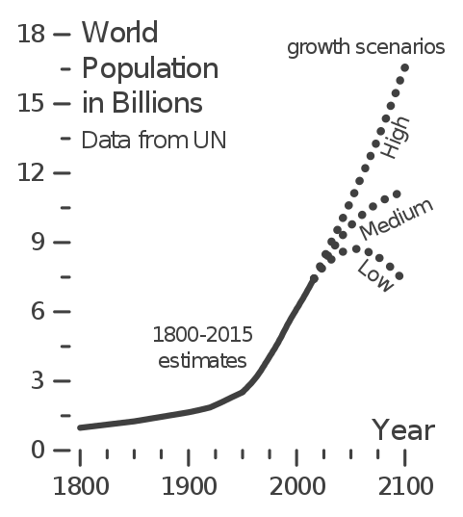

It represents everyone with whom you share this world. It represents everyone with whom you, and especially children, might share this world in the future.

Many things happen in the world, the things we read about every day: Climate change begins to manifest itself, countries allow despots to come to power, the gap between rich and poor widens, parents and strangers abuse and kill helpless children. But here’s a thought: What you see on the graph happened first. Before the people with whom we share this world do all of the things that define the world around us, and determine the changing quality of our lives, they are first brought into the world. We are, before we do, and actors precede actions. And the different directions we might go in terms of who comes into the world, the different forks on the graph, depends on something as small but profound as whether the [average woman in the world today has one child more, or on child less](https://ourworldindata.org/future-population-growth) in her lifetime.

How would we know the right path to take? Could it be as simple as changing the perspective from which we consider family planning, from the perspective of parents alive today to one that includes the children we might have in the future – the ones with the most interest in family planning?

The truth is, for all its importance, we rarely talk about family planning in this sense because, like the subject of climate change, our brains [can’t process something so large, slow-moving, and amorphous](https://www.theguardian.com/sustainable-business/2014/nov/10/brain-climate-change-science-psychology-environment-elections).  We also avoid the topic because it is fraught with controversy. For some children are a gift from god that cannot be interfered with. For others family planning brings out from the shadows the worst sort of bogeymen: The American eugenics movement, China’s one-child policy, roving sterilization units on the streets of New Delhi, Romania’s Ceaușescu forcing women to become pregnant and bear children for the state.

Those horrors are why today, in most of the world, whether someone has one child or ten, whether those kids are born into millions or destitute, is for the parents alone to decide as a matter of personal right and privacy. Most law and culture reinforces the norm that, simply put, family planning is [nobody else’s business](http://thestir.cafemom.com/celebrities/205970/kate_middleton_prince_william_babies). And to the extent there is public pressure, it’s often for people to have more kids irrespective of the conditions in which they will be born, pressure [subtly applied by the governments and big businesses](https://www.theatlantic.com/politics/archive/2017/12/pro-natalism/547493/) that thrive on the steady flow of new consumers, consumers who eventually and conveniently become cheap labor in a glutted market, as well as useful taxpayers.

But is that how we really feel about family planning? We care about kids and their welfare. How can we not then care about, and earnestly work to improve, the conditions in which they are born? Isn’t that just being smart, and thinking ahead to maximize our impact? We care about the environment. How can we not care about the behavior that, [more than anything else](https://www.forbes.com/sites/janetwburns/2017/07/20/scientists-say-family-planning-is-our-best-bet-to-reduce-climate-change/#4c8b4dd40f5e), is destroying it? Do we want to leave any room for animals in the planning of our families, or is it their role to [become extinct in the path of our growth](https://www.washingtonpost.com/news/speaking-of-science/wp/2017/07/12/earth-is-on-its-way-to-the-biggest-mass-extinction-since-the-dinosaurs-scientists-warn/?utm_term=.852a9651690d)? We care about the gulf between rich and poor. How can we not care about the isolationist family planning that is [widening it every day](https://fivethirtyeight.com/features/rich-kids-stay-rich-poor-kids-stay-poor/)?

Family planning is at the heart of many of the headlines we read every day:  A [federal judge offers a mother of seven](https://www.washingtonpost.com/news/true-crime/wp/2018/02/08/judge-suggests-drug-addicted-woman-get-sterilized-before-sentencing-and-she-does/?utm_term=.fda01308f1d1), who was unable to mother her children rather than her addictions, sterilization as a way to reduce her criminal sentence. China once-again considers [changing its family planning policies](https://www.economist.com/news/china/21736574-two-child-rule-still-applies-officials-know-more-babies-are-needed-not-fewer-china), in a new violation of human rights, to push women to have babies to drive its economic growth. Popular reality shows feature large families, and some [commentators hold them up as role models](http://thefederalist.com/2018/01/05/chip-joanna-gaines-baby-five-people/) while others decry [the parents’ irresponsibility](https://www.usmagazine.com/celebrity-moms/news/chip-and-joanna-gaines-slammed-for-baby-no-5/). Congress, also thinking about economic growth, [cuts access to family planning](https://www.nytimes.com/2017/10/06/us/politics/trump-contraception-birth-control.html), and expressly chooses [a tax policy intended to encourage women to have more kids](https://www.theatlantic.com/politics/archive/2017/12/pro-natalism/547493/). In the debate over child abuse, and the now infamous couple in California who tortured their thirteen-kids, one influential think tank [urges prioritizing parental rights](http://www.latimes.com/opinion/op-ed/la-oe-riley-turpin-child-welfare-law-20180206-story.html). The outcomes of these controversies will help determine the people we bring into the world, the people with whom we will all share the world.

Which way, on the graph above, will we go? Here’s one way to think about any controversy that, directly or indirectly, involves family planning. From whose perspective, and using which values, are we considering the decision to have kids? Are we stuck with the “nobody else’s business” and parent-centered model of having kids? What if instead we considered it from a future child’s perspective, and proceeded from - and based our thinking upon - fundamental values like ensuring every child a good and loving home, a fair start in life relative to their peers, and a clean and safe environment? Which path, on the graph above, would we choose if we were looking at it from a future child’s perspective? Changing the perspective from which we consider the future we want, from the subjectivity and immediacy of the parent-centered model to the perspective of the people who will primarily occupy that future, can help break the paradigm that has kept us from taking family planning seriously and dealing with it, and all of its controversies, publicly.

The change could be as simple as moving past the “nobody else’s business” model, which makes an open, honest public conversation about the topic taboo, to instead saying this: *Child first family planning means working with your community to get the resources you deserve to give your child a fair start in life, with equal opportunities relative to their peers, and planning a smaller and sustainable family where you can invest more in each child.*

How would we begin to implement that change – the child first method of family planning – in our laws and policies? It’s not as hard as we think – and involves a straightforward remodeling of very specific aspects of our state and federal tax and family law policies, as well as our health care and child welfare systems. There are specific ways to change reactive child tax credits into proactive family planning incentives tied to equity-based saving accounts, alter climate policies to consider the need for a [smaller, more resilient, and more cooperative populace](https://www.washingtonpost.com/news/wonk/wp/2016/01/01/small-families-are-better-for-kids-according-to-new-research/?utm_term=.def29edda55b) capable of thriving in a more environmentally challenging future, move child protection systems from reaction to prevention though the use of criminal justice system reforms that prevent convicted child abusers from having additional children, etc.

Family planning is at a crossroads, and the threats of climate change, child abuse, inequality and many others are upon us. We don’t have to ignore these problems, and shuffle them off to be dealt with, once again, by next generations. If we care about kids, our environment, fairness, and all the other immediate issues that family planning subtly impacts, we will prioritize thinking about the graph above when developing our public policies, and more importantly, choosing the right path towards a brighter future.